

MalFunc
19/06/2026
Submitted to Prof. Arslan Ahmad
Faizan Toheed(018), Muhammad Rohan Jabbar(019), Shah Faisal Ilyas(033), Muhammad Usman(044)
University of Management and Technology
Course: Introduction to Data Science
Section: D2

Overview
The MalFunc library consists of functions that we want to use daily but are not built-in, meaning we usually have to write code for them from scratch. This library covers basic functions to help beginners learn the programming language better, and it also provides useful tools for developers.

Goals
The MalFunc library primarily focuses on lists. It consists of two modules with the following main goals:
- To create functions for calculations, such as introducing vectorized functions.
- To create utility functions for in-depth list analysis, such as finding the data types (dtypes) of each element in a list.

Working of the Library
Here is what we will show you about the library:
- How to install the library.
- Details about Module 1 (ops.py).
- Details about Module 2 (utils.py).
- Unit tests for each function

Installing the Library
Here is the command which you can use to install the library:
‘pip install malfunc-faizantoheed456’
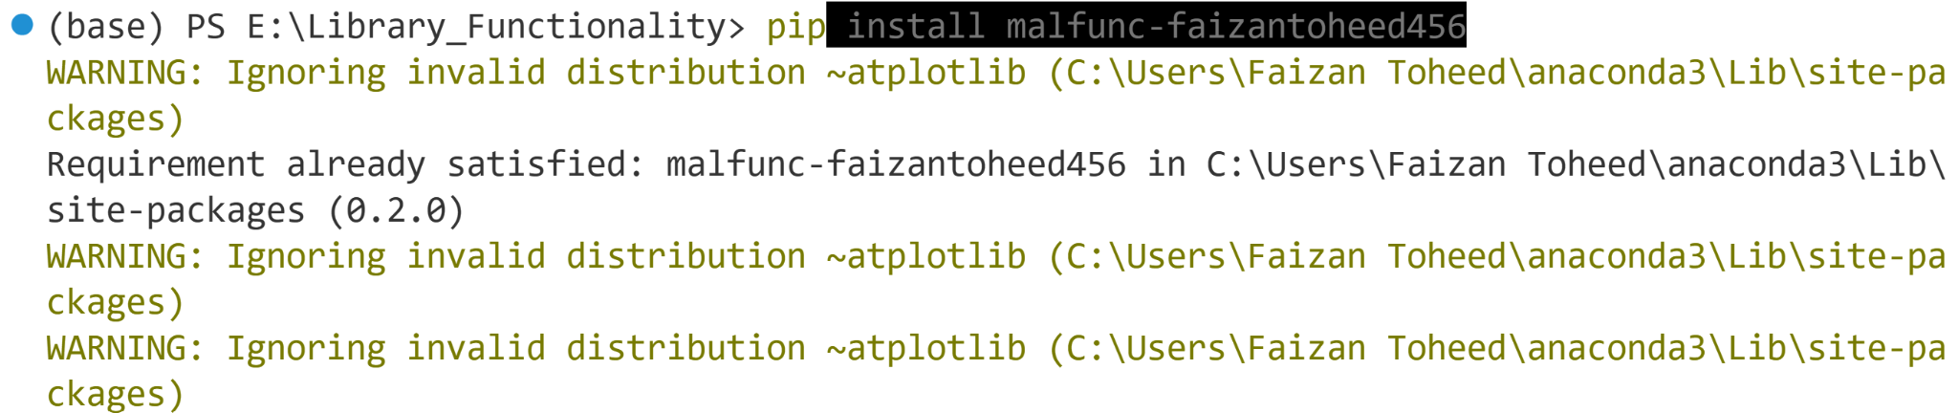
Because I already have it installed on my system so it show Requirement already satisfied statement.

Details about Module 1 (ops.py)
This module contains five functions that perform helpful mathematical and structural operations on lists.

get_number(prompt, to_int=False):
This module contains five functions that perform helpful mathematical and structural operations on lists.

get_sum(list):
Calculates the sum of numbers in a list, even if the list has nested loops or non-numeric items.

get_mul(list):
Multiplies all the numbers in a list together while ignoring invalid data types like strings.

get_indices(list):
Finds and maps the exact index paths of all items inside a deeply nested list.

vectorize_sum(a, b):
Performs element-wise addition between two lists to combine them seamlessly.

Details about Module 2 (utils.py)
This module contains four utility functions designed for advanced list manipulation, flattening, and data type analysis.

vectorize_mul(a, b):
Multiplies two lists element-by-element without needing external libraries like NumPy.

get_unique_order_list(data):
Removes duplicate items from a list while keeping all the remaining items in their original order.

get_flat(data):
Takes a deeply nested list and flattens it completely into a single, easy-to-use list.

get_dtypes(data):
Counts and analyzes all the different data types present inside a mixed collection or list.

Unit test for each function
We wrote comprehensive unit tests for all 9 functions to make sure they handle errors correctly and process data accurately.
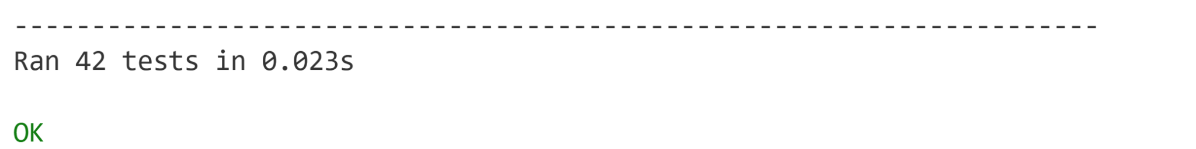

FUNCTIONS AND THEIR OUTPUTS

get_number(prompt, to_int=False)
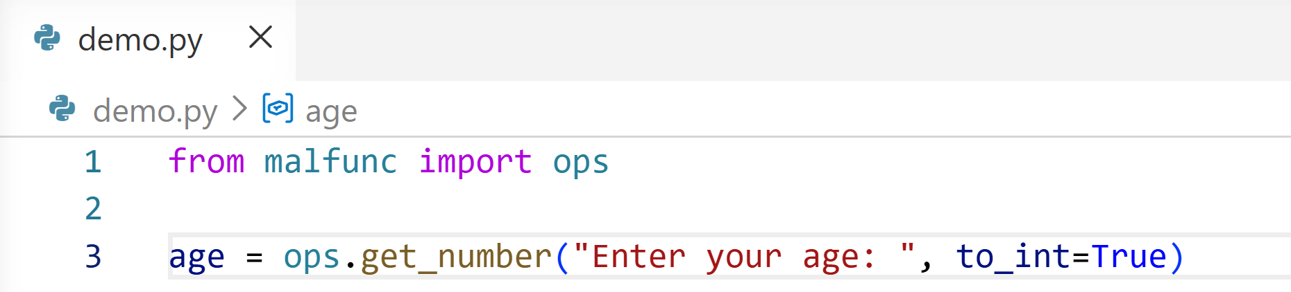
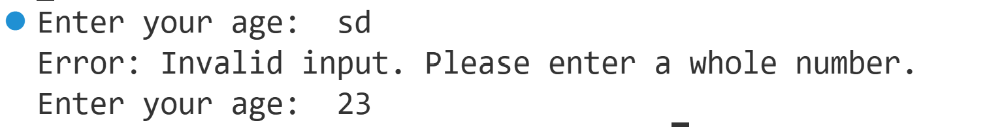

get_sum(list)
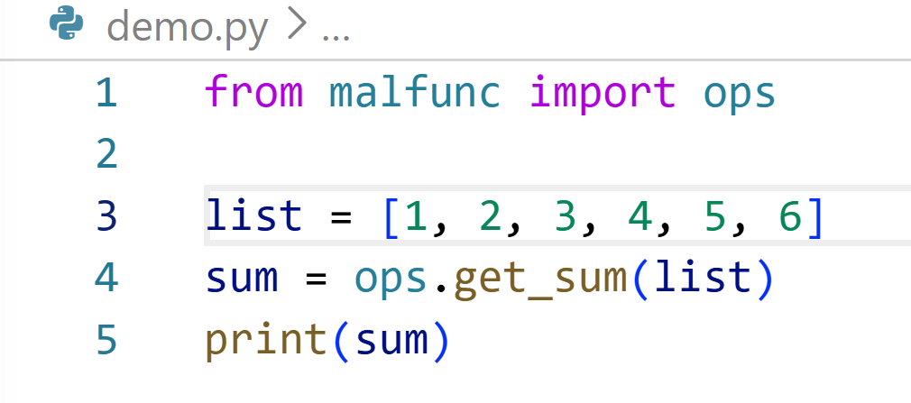

get_indices(list)
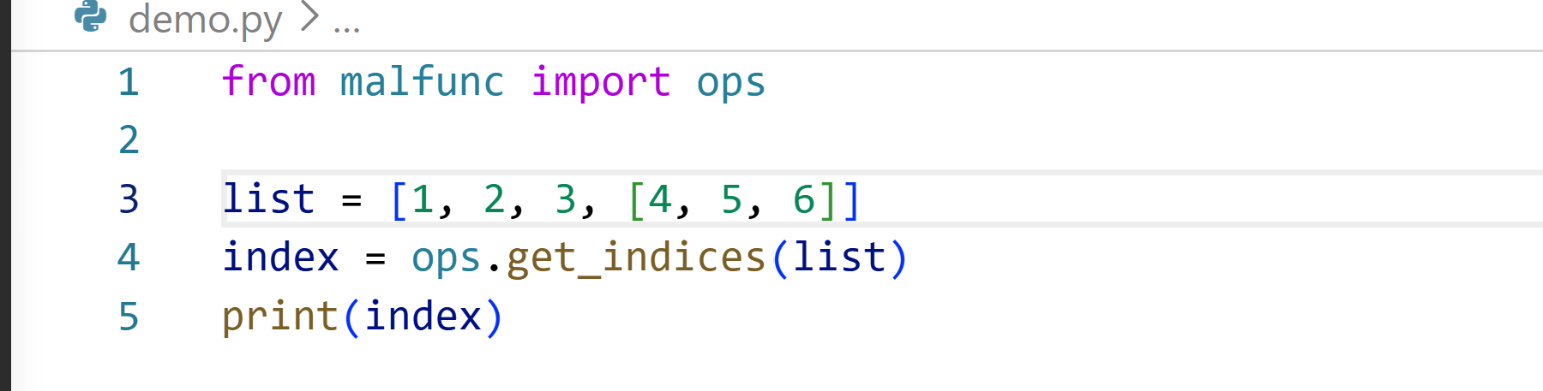

get_mul(list)
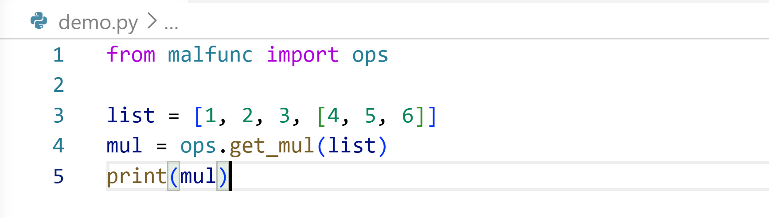


vectorize_mul(a, b)
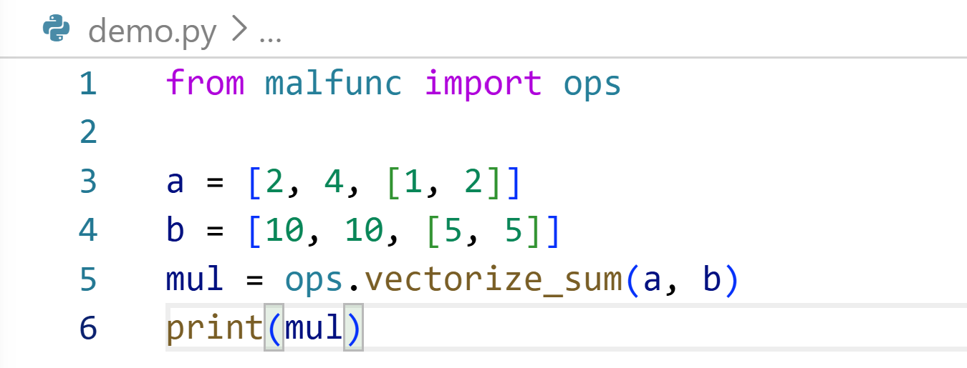


vectorize_mul(a, b)
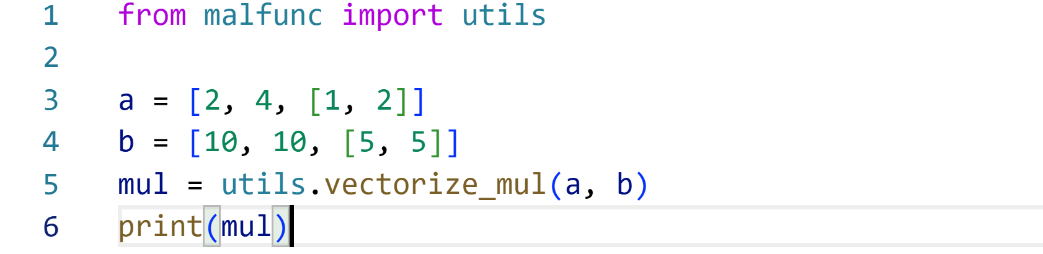

get_unique_order_list(data)
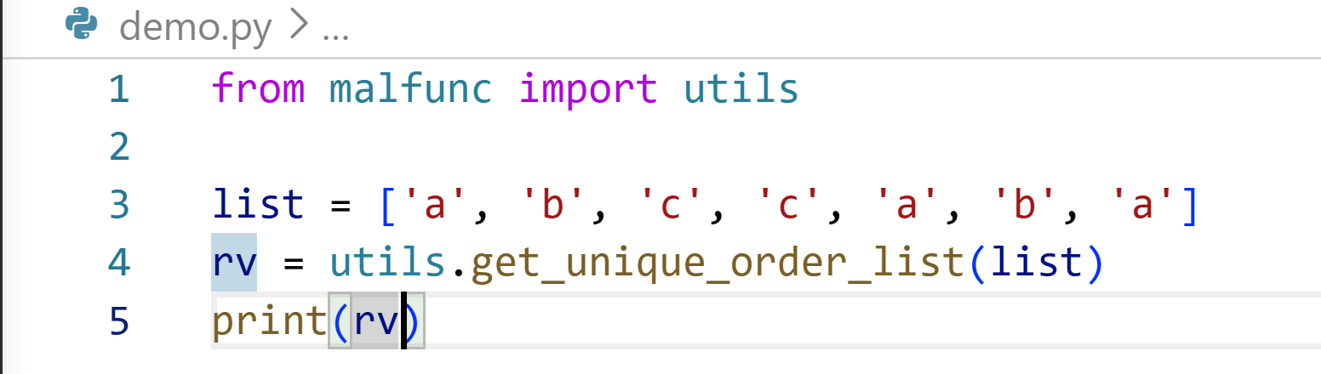

get_flat(list)
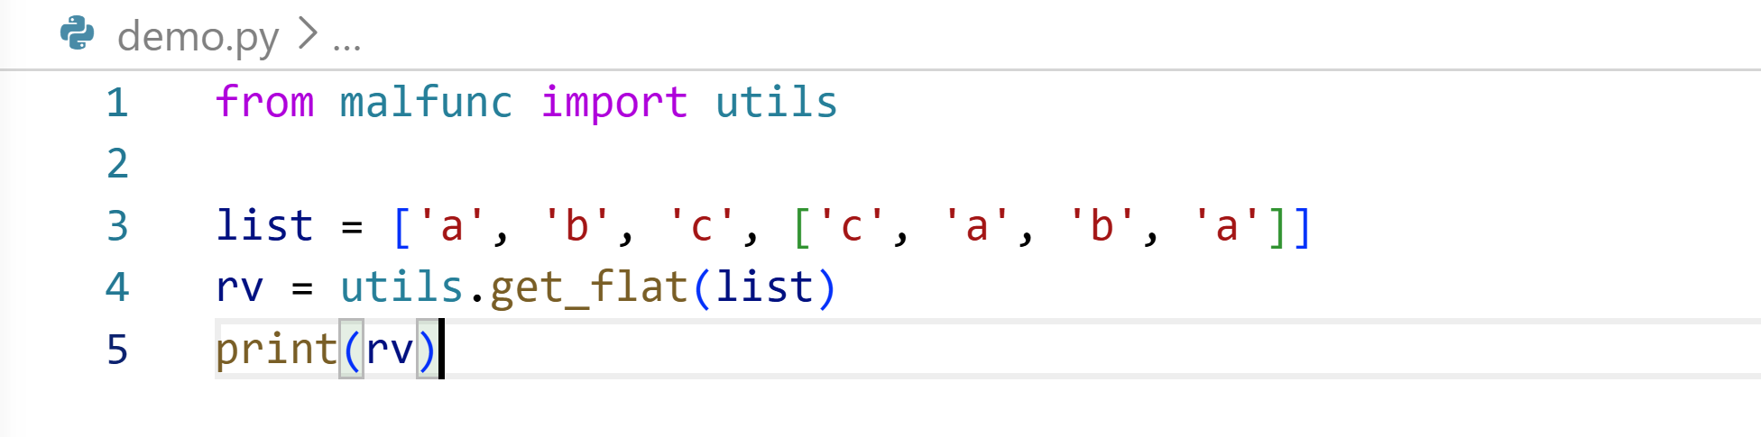

get_dtypes(list)
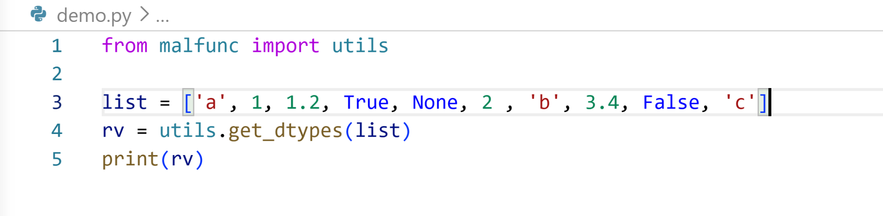

Pypi Website proof
